**Traffic Sign Recognition**

**The goals/ steps of this project are the following:**

* Load the data set (see below for links to the project data set)
* Explore, summarize and visualize the data set
* Design, train and test a model architecture
* Use the model to make predictions on new images
* Analyze the softmax probabilities of the new images
* Summarize the results with a written report

**Data Set Summary & Exploration**

1. Provide a basic summary of the data set

Number of training examples = 34799

Number of testing examples = 12630

Image data shape = (34799, 32, 32, 3)

Number of classes = 43

1. Visualization of all types of data set

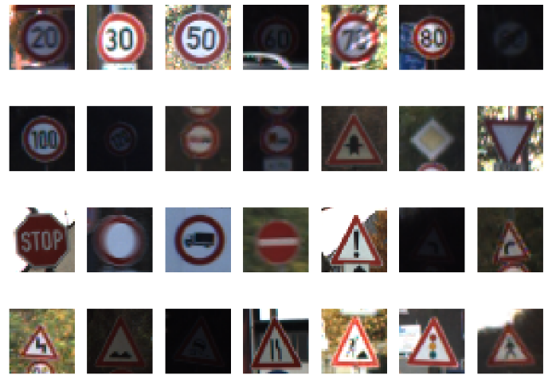

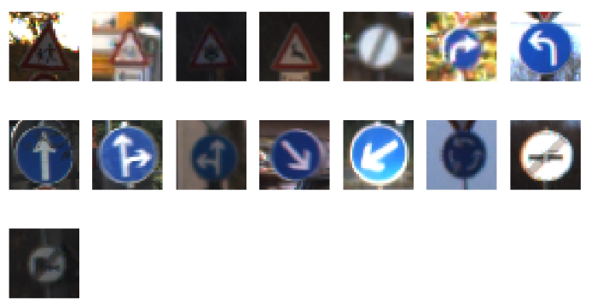

Design and Test a Model Architecture

1. Describe how you preprocess the image data.

convert original images to gray and normalized images

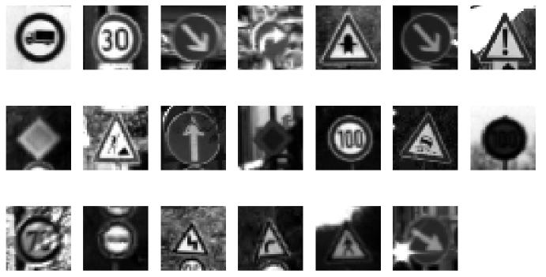

1. Describe what your final model architecture

My final model is a night-layer VGG-like CNN:

|  |  |  |  |
| --- | --- | --- | --- |
| **Layer** | **Input size** | **Output size** | **description** |
| Conv1 | 32*32*1 | 30*30*16 | strides=[1, 1, 1, 1] |
| Conv2 | 30*30*16 | 28*28*32 | strides=[1, 1, 1, 1] |
| Pooling | 28*28*32 | 14*14*32 | strides=[1, 2, 2, 1] |
| Conv3 | 14*14*32 | 12*12*64 | strides=[1, 1, 1, 1] |
| Conv4 | 12*12*64 | 10*10*128 | strides=[1, 1, 1, 1] |
| Conv5 | 10*10*128 | 8*8*256 | strides=[1, 1, 1, 1] |
| Pooling | 8*8*256 | 4*4*256 | strides=[1, 2, 2, 1] |
| FullConn6 | 4096 | 2400 |  |
| FullConn7 | 2400 | 800 |  |
| FullConn8 | 800 | 400 |  |
| FullConn9 | 400 | 43 |  |

1. Describe how you trained your model.

I used the AWS EC2 GPU to train my model.

* learning_rate = 0.001
* batch_size = 128
* training_epochs = 35
* mu = 0
* sigma = 0.1

1. Describe the approach taken.

My final model results were:

* Validation set accuracy is 94.6%
* Test set accuracy is 93%

Test a Model on New Images

1. Choose ten German traffic signs online

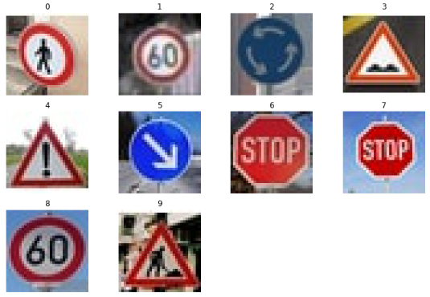

1. Discuss the model’s predictions on these new data

|  |  |
| --- | --- |
| **image** | **prediction** |
| Yield | Yield |
| 60km/h | 60km/h |
| Roudabout mandatory | Roudabout mandatory |
| Bumpy road | Bumpy road |
| General caution | General caution |
| Keep right | Keep right |
| Stop | Stop |
| 60km/h | 50km/h |
| Road work | Road work |

The model was able to correctly guess 9/10 traffic signs, which gives an accuracy of 90%

The top five soft max probabilities were:

